Kali Charan Nigam Institute

of Technology Banda

Session : 2022-23
Department of Computer Science & Engineering
A Mini Project Report File (KCS-354)
On
‘Typing Speed Test’

Bachelor of Technology
in
Computer Science & Engineering
Under the guidance
of
Mr. Pradeep Sachan

Submitted to Submitted by
Mr. Jitendra Nishad Pranjal Chakravarti
2101390100052

Table of Contents
1. Projec tProblem Statement………………………………………………………………
2.Introduction………………………………………………………………………………
- Project file statement………………………………………………………………
- Install Tkinter………………………………………………………………………
- Importing Libraries…………………………………………………………………..
- Initializing test window and variables…………………………………………………
- Function for making the text float on the top of the window………………………….
- Function for declaring result……………………………………………………….

Defining labels……………………………………………………………………….

3. System specification……………………………………………………………………
- Hardware Requirements………………………………………………………….
- Software Requirements……………………………………………………………

4. Software Description……………………………………………………………………
- PYTHON 3.6.0 IDLE 2016
- Development Tools and Technologies
- PYTHON 3.10
- GUI (GRAPHICAL USER INTERFACE)
5. System Testing………………………………………………………………………….
- Introduction…………………………………………………………………………
- Steps…………………………………………………………………………………
- Testing methodologies………………………………………………………………
- Unit Testing…………………………………………………………………………
- Integration Testing…………………………………………………………………
- System testing………………………………………………………………………
- Performance testing…………………………………………………………………
6. System Implementation…………………………………………………………………
- Purpose………………………………………………………………………………
- System maintenance…………………………………………………………………
7. Conclusion and Future Enhancements……………………………………………………
8. Abstract……………………………………………………………………………………
- Output Screenshot………………………………………………………………………….

Project Problem Statement
In this python project, we shall figure out how to make a speed typing test using python. It's an extremely helpful project to keep track of our typing speed and improve it with regular practice. This mini python project is very interesting, simple and best for practice purposes. Speed Typing Test is a python based system that will check the our-typing speed in wpm (word per minute), accuracy, correct & wrong words, most missed words, most inaccurate words, etc. This can be pretty and useful and helpful for those people who are not good at typing, they can do this test and get to know where they need to improve.

Introduction of ‘Typing Speed Test’
In this Python project idea, we are going to build an exciting project through which you can check and even improve your typing speed. For a graphical user interface, we are going to use the Tkinter library which is used for working with graphics user interface . We will draw the images and text to be displayed on the screen.
The project in Python requires you to have basic knowledge of python programming and the tkinter library.

Project File Structure
1. Install Tkinter
2. Importing Libraries
3. Initializing test window and variables
4. Function for making the text float on the top of the window
5. Function for declaring result
6. Defining labels

1. Install Tkinter:
Tkinter is a standard graphical user interface library that is available for python. You need to install Tkinter to begin the project. Write the command given below to install Tkinter on your system.
pip install tkinter

2. Importing Libraries:

from tkinter import *
import random
from time import sleep
import threading

random: It helps in generating random strings and numbers.
sleep : Delay execution for a given number of seconds. The argument may be a floating point number for subsecond precision.
threading : Thread module emulating a subset of Java's threading model.

3. Initializing test window and variables:
root = Tk()
root.resizable(0,0)
root.geometry('850x531')
root.title("Typing Test by Pranjal Chakravarti")
root.iconbitmap(r'C:\Users\dell\Desktop\mini project\logo.ico')
root.mainloop()

Code Explanation:
a. Tk(): It helps in initializing the tkinter module.
b. geometry(): It defines the geometry of the typing test window.
c. title(): It displays the title on the top of the typing test window.
d. resizable(): It resize the output screen.
e. iconbitmap(): It is used for using icon.
f. mainloop(): Call the mainloop of Tk.

4. Function for making the text float on the top of the window:
label_paragraph=Label(root,text=paragraph_list[0],font=('arial 13 bold'),bg='#f3fcda',fg='#535353',bd=0)
label_paragraph.place(x=10,y=10)

def count():
global wrongwords
while time!=totaltime:
entered_paragraph=textarea.get(1.0,END).split()
totalwords=len(entered_paragraph)
totalwords_count_label.config(text=totalwords)
para_word_list=label_paragraph['text'].split()

5. Function for declaring result
def start_timer():
def count():
def start():
def reset():
def Exit():
root.destroy()

Defining labels:
bg=PhotoImage(file=r'C:\Users\dell\Desktop\mini project\bg.png' )

lab=Label(root,image=bg)
lab.pack()

welcome=Label( root,text="Welcome to Pranjal's typing test", font=('arial 10'),bg='#D2F59F')
welcome.place(x=632,y=13)

elapsed_time_label=Label(root,text=' Elapsed Time : ',font='algerian 15 bold' , bg='#D2F59F')
elapsed_time_label.place(x=590,y=50)

elapsed_timer_label=Label(root,text='0',font='algerian 15 bold' , bg='#D2F59F')
elapsed_timer_label.place(x=760,y=50)

remaining_time_label=Label(root,text='remainning Time : ',font='algerian 15 bold' , bg='#D2F59F')
remaining_time_label.place(x=590,y=80)

remaining_timer_label=Label(root,text='60',font='algerian 15 bold' , bg='#D2F59F')
remaining_timer_label.place(x=790,y=80)

wpm_labe=Label(root,text='wpm : ',font='algerian 15 bold' , bg='#D2F59F')
wpm_labe.place(x=590,y=110)

wpm_count_label=Label(root,text='0',font='algerian 15 bold' , bg='#D2F59F')
wpm_count_label.place(x=665,y=110)

totalwords_label=Label(root,text='Total words : ',font='algerian 15 bold' , bg='#D2F59F')
totalwords_label.place(x=590,y=170)

totalwords_count_label=Label(root,text='0',font='algerian 15 bold' , bg='#D2F59F')
totalwords_count_label.place(x=750,y=170)

wrongwords_label=Label(root,text='wrong words : ',font='algerian 15 bold' , bg='#D2F59F')
wrongwords_label.place(x=590,y=200)

wrongwords_count_label=Label(root,text='0',font='algerian 15 bold' , bg='#D2F59F')
wrongwords_count_label.place(x=760,y=200)

accuracy_label=Label(root,text='accuracy : ',font='algerian 15 bold' , bg='#D2F59F')
accuracy_label.place(x=590,y=140)

accuracy_percent_label=Label(root,text='0',font='algerian 15 bold' , bg='#D2F59F')
accuracy_percent_label.place(x=720,y=140)

label_paragraph=Label(root,text=paragraph_list[0],font=('arial 13 bold'),bg='#f3fcda',fg='#535353',bd=0)
label_paragraph.place(x=10,y=10)

Code Explanation:
a. Label(): It is used to implement display boxes.
b. place(): It defines the place of the label on the screen.

SYSTEM SPECIFICATION

4.1 HARDWARE REQUIREMENT (minimum requirement] :

# Minimum RAM: - 1GB
# Minimum Hard Disk: - 128GB
Processor: - Intel Pentium 4(2.50 GHz) or above

SOFTWARE REQUIREMENT (minimum requirement] :
# Operating System: - Support for both LINUX and WINDOWS users
# Back End: - Python 3.6.0 Interpreter
# Front End Language: - Python3
# Front Design: - Tkinterface

SOFTWARE DESCRIPTION
5.1
PYTHON 3.6.0 IDLE 2016
IDLE stands for integrated Development and Learning Environment is an integrated development environment for python. It has been bundled with the default implementation of the language since 1.5 2.1. It is packaged as an optional part of the python packaging with many Linux distribution. It is completely written in python3 and Tkinter GUI toolkit IDLE is intended to be a simple IDE and suitable for beginners as well as advanced users. To that end it is cross platform and avoids feature clutter. The features provided by the IDLE includes: #Python shell with syntax highlighting
#integrated debugger with stepping, persistent breakpoints and call stack visibility
#Multi-window text editor with syntax highlighting, auto completion, smart
Indenting etc.

5.2 DEVELOPMENT TOOLS AND TECHNOLOGIES
5.2.1 PYTHON 3.10:
Python is a general purpose interpreted, interactive, object-oriented, and high-level programming language. It was created by Guido Van Possum during 1985-1990 Like Perl, Python source code is also available under the GNU General Public License (GPL) Python is named after a TV show called "Monty Python's Flying Circus".
Python 3.0(also called "Python 3000 or "Py3K") was released in December 3, 2008. The latest version of python accumulated new and redundant ways to program the same task, Python 3.6 had an emphasis on removing duplicative constructs and modules, in keeping with 'There should be one and preferable only one - obvious way to do it". Python's dynamic typing encourage the programmer to write a code that is clear, well structured as well as easy to understand. The features of dynamic typing are
# Types are bound to values but not to variables
# Function and method lookup is done at runtime
# Values are inspect-able.
# there is an interactive interpreter, more than one, in fact
#you can list the methods supported by any given object
Because code is automatically compiled to byte code and executed, Python is suitable for use as a scripting language, Web application implementation language etc. Because of its strong structuring constructs (nested code blocks, functions, classes, modules and packages) and its consistent use of objects and OOP, Python enables you to write clear and logical code for small and large projects

5.2.2 GUI (GRAPHICAL USER INTERFACE):

Our goal in this article is to provide you with an introductory of GUI programming In order to learn the GUI programming, you must first understand a few core aspects of GUL so let's begin the discussion. The primary GUI toolkit will be using Tk, Python's default GUI We'll access Tk from its python interface called Tkinter. It is not the latest and greatest nor does it have the most robust set of GUI building blocks, but it is fairly simple to use and using it, you can build GUI's that run on most platforms. Setting up GUI application is similar to how an artist produces a painting Conventionally there is a single canvas onto which the artist must put all the work In GUI programming a top-level root windowing object contains all of the little windowing objects that will be a part of your GUI application. These can be text labels, buttons, list boxes etc. These individual little GUI components are known as widgets Top level windows are those that show up stand alone as part of your application Interestingly, you can have more than one top level window for your GUI, but only one of them should be your root window.
The top level window can be created using this
Import tkinter

top=tkinter. Tk ()

The object returned by tkinter.tk () is usually referred to as the root window. Within this window you can place multiple component pieces together to form your GUI. Tk has three geometry managers that help with positioning your widget set
# Placer: You provide the size of the widgets and locations to place them, this manager then places them for you.
# Packer: It packs widgets into the correct places
# Grid: It is used to specify GUI widget placement based on grid Coordinates
Now once the packer has determined the sizes and alignments of your widgets, it will then place them on the screen for you. When all the widgets are in place we instruct the application to infinite main loop In Tkinter the code that does it is
Tkinter.mainloop ()
This is normally the last piece of sequential code your program runs

SYSTEM TESTING

7.1 INTRODUCTION
Once source code has been generated, software must be tested to uncover and correct as many errors as possible before delivery to customer. Our goal is to design a series of test cases that have a high likelihood of finding errors. To uncover the residual errors software techniques are used. These techniques provide systematic guidance for designing test that
# Exercise the internal logic of software components, and
# Exercise the input and output domains of the program to uncover errors in program
Function behavior and performance
7.1.1
STEPS:
Software is tested from two different perspectives
#Internal program logic is exercised using -White box test case design techniques
# Software requirements are exercised using block box test case design techniques in both cases, the intent is to find the maximum number of errors with the minimum amount of effort and time and cost.
7.2
TESTING METHODOLOGIES:
A strategy for software testing must accommodate low-level tests that are necessary to verify that a small source code segment has been correctly implemented as well as high level tests that validate major system functions against customer requirements. A strategy must provide guidance for the practitioner and a set of milestones for the manager. Because the steps of the test strategy occur at a time when deadline pressure begins to rise progress must be measurable and problems must surface as early as possible. Following testing techniques are well known and the same strategy is adopted during this project testing

7.2.1 UNIT TESTING:
Since this is a game which may have various forms of user input, it would be nearly impossible to test every possible user combination. However, testing functionality and likely user scenarios should be our overall goal of testing Tic-Tac-Toe. Unit testing focuses verification effort on the smallest unit of software design-the software component or module. The unit test is white-box onented. The unit testing is Implemented in every module of this project by giving correct manual input to the system, the inputted data are stored in database and can be retrieved. If you want required module to access input or get the output from the End user, any error will accrue that time will provide handler to show what type of error will accrued.

7.2.2 INTEGRATION TESTING:
First and most importantly we will ensure the tkinter builds and runs without errors. Also make sure it still works while embedded. GUI should display correctly on the root window. There should be no states which freeze the game. Switching between the players should update seamlessly and no logical errors should occur. All warnings (highlights) should be identified by the game state and displayed correctly by the GUI. All in all, a full game should be playable without programming or logical errors.
7.2.3 SYSTEM TESTING:
System testing is actually a series of different tests whose primary purpose is to fully exercise the computer-based system. Below we have described the two types of testing which have been taken for this project. It is to check all modules worked on input basis. If you want change any values or inputs, it will change all information, so specified input is must. System testing can be stated as the process of validating and verifying that a computer program / application/product:
- meets the requirements that guided its design and development
- Works as expected
- can be implemented with the same characteristics
- satisfies the needs of stakeholders.
7.2.4 PERFORMANCE TESTING:
Performance testing is designed to test the run-time performance of the software within the context of an integrated system. Performance testing occurs throughout all steps in the testing process. Even at the unit level, the performance of an individual module may be assessed as white-box tests are conducted.
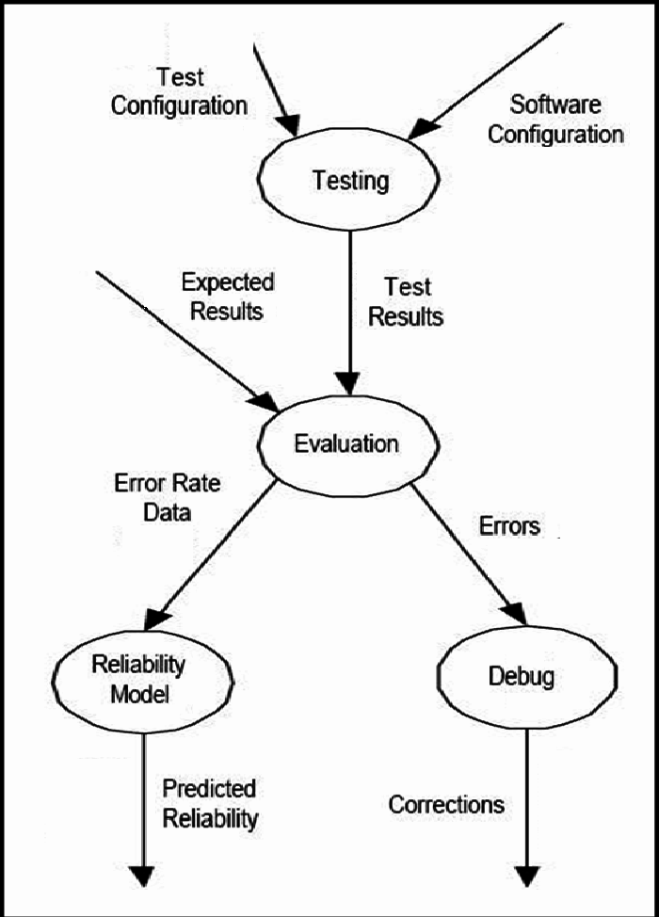
SYSTEM IMPLEMENTATION
8.1
PURPOSE
System implementation is the important stage of project when the theoretical design is tuned into practical system. The main stages in the implementation are as follows
# Planning
# Training
# System testing and
# Changeover Planning
Planning is the first task in the system implementation. At the time of implementation of any system people from different departments and system analysts involve. They are confirmed to practical problem of controlling various activities of people outside their own data processing departments
8.2 SYSTEM MAINTENANCE
Software maintenance is far more than finding mistakes. Provision must be made for environment changes, which may affect either the computer, or other parts of the computer based systems. Such activity is normally called maintenance. It includes both the improvement of the system functions and the corrections of faults, which arise during the operation of a new system. It may involve the continuing involvement of a large proportion of computer department recourses. The main task may be to adapt existing systems in a changing environment. Back up for the entire database files are taken and stored in storage devices like flash drives, pen drives and disks so that it is possible to restore the system at the earliest. If there is a breakdown or collapse, then the system gives provision to restore from database files. We focus on four types of maintenance
    - Adaptive Maintenance
    - Perfective Maintenance
    - Corrective Maintenance
    - Preventive Maintenance

CONCLUSION AND FUTURE ENHANCEMENTS

These days, typing can seem like it is not such an important skill as it once was. For example, we are becoming increasingly used to talking to our machines with the advances being made by Google Home, Alexa, Cortana, and Siri.
But typing remains a fundamental skill, and it is still one of the most important computer skills you can learn. Learning to type fast and accurately will help you in many ways in life, and it should be considered an essential skill for anyone who sees themselves working with a computer in some capacity
Save Time
Typing is something most of us will have to do a lot of in our jobs. Whether you work in an office or not, you will probably end up having to type on a computer keyboard on a weekly or even daily basis.
It stands to reason that the faster you can type, the more time you will save.
When you are tasked with typing up a report, or even when you have to send an email, if you can do so quickly while remaining accurate, you could end up saving a lot of time.
Just think of all those emails most people send every day. Add up the time you can save typing up each email, and over the weeks and months that could add up to a lot of saved time.

Be More Productive
Everyone is looking for ways to be more productive both in the workplace and at home, and typing faster is a simple way to get more done.
If you learn to double the speed you type, you can essentially get twice as much done in the same space of time.
Employers might even want to ensure their employees are trained up in touch-typing due to the productivity boost it could lead to.
And if you are an employee, you could learn how to increase your typing speed to impress your boss, or you can simply give yourself more time to spend on other things.

Improve Your Posture
Posture may not be the first thing you think about when you decide to increase your typing speed, but it can certainly benefit.
No matter whether you can touch type or not, you will still spend a lot of your time typing in almost any office-based role. Everyone knows that sitting down at your desk for long periods of time without a break is bad for your posture, so it makes sense to reduce the amount of time you sit down.
If a lot of your time sitting at your desk is spent typing, you might be able to improve your posture and your health by increasing your typing speed. This will mean less time spent typing at your desk, and that will lead to more time spent standing up and stretching so as not to hurt your back, neck, and shoulders.

Improve Your Focus
Another benefit of learning to type faster is that you will not have to look at the keyboard and think about where your fingers are going. Once you are typing fast, you will be able to look directly at the screen, and your fingers will type without you even thinking about the movements.
This means that you will be able to improve your focus. Every time you look down and try to find a key, you are losing concentration, so you will be able to focus more on what you are trying to say than the actual letters that you are typing.
So learn how to type properly and improve your focus, which will lead to a better flow and your thoughts won't be interrupted as much.

Better Accuracy
Learning to touch type is not just about learning how to type faster: It's also about learning how to type with greater accuracy.
Some online tools can help you learn to type faster and also highlight your mistakes in the moment so you can focus on reducing them.
That means you will spend less time checking for mistakes in your writing and correcting them, saving you yet more time and making less work for you. It will also mean that there is less chance that mistakes will sneak through into the final version of the document.

Find More Opportunities
Finally, because touch-typing is such a useful skill that boosts productivity in the workplace, it can help you to find more and better opportunities when it comes to getting a job.
When applying for a job, being able to type fast and accurately is going to put you at a big advantage. Employers like to know that their employees can type properly because it will make them more productive and improve the accuracy of their work.
So make sure you clearly state your word per minute (WPM) on your resume to impress prospective employers, and you may find that more opportunities come your way.

Transcriptionist

Journalism

Coders

Data Entry

Social Media Management

Subtitling

Blog Writer

Many jobs required a fastest typist , if you have fast typing skill then many jobs available for you . So fast typing is an important skill in digital field and in a future all fields will be digitalized.

Abstract

Python Typing Test Output:
